**Locking and Overlapping with**

**Augmented Reality**

Table of Contents

Abstract 3

Chapter 1: Introduction 3

Chapter 2: Augmented Reality 4

2.1 Introduction 4

2.2 Brief history of augmented reality 4

2.2.1 First Augmented Reality (HMD) 4

2.2.2 Videoplace 5

2.2.3 AR Powered User Manual 5

2.2.4 ARToolKit 5

2.3 Augmented Reality on Smartphones 6

2.3.1 Android OS 6

2.3.2 iOS 6

2.4 Challenges with Augmented Reality on Smartphones 6

2.4.1 Battery Consumption 6

2.4.1 Camera Quality 6

2.4.2 Network Dependency 7

2.5 Challenges AR faced both in development and social acceptance 7

2.5.1 Development Challenges 7

2.5.2 Social Acceptance Challenges 8

2.6 Augmented Reality in Other fields 8

2.6.1 Augmented Reality in Gaming 8

2.6.2 Augmented Reality in Education 9

2.6.3 Augmented Reality in Media & Advertisement 9

2.7 The Differences between Augmented Reality and Virtual Reality 10

2.8. Simultaneous Localization and Mapping (SLAM) 10

2.9 Marker-Based and Marker-less Augmented Reality 11

2.9.1 Marker-Based AR 11

2.9.2 Marker-less AR 12

3. Augmented Reality Environment Technologies 12

3.1 AR SDKs 12

3.1.1 Vuforia AR SDK 12

3.1.2 Use of Vuforia 12

3.1.2 Kudan AR SDK 13

3.2 Unity 3D Game Engine 13

Chapter 4: Methodology & Design 14

4.1 Key Findings 14

4.2 Research Question 14

4.3 Project Proposal 14

4.4 System Design 14

4.4.2 Prototypes 15

4.4.3 Prototype Screenshots 16

Chapter 5: Implementation 16

**References** 17

# Abstract

# Chapter 1: Introduction

//Leave until the end

# Chapter 2: Augmented Reality

## 2.1 Introduction

Augmented reality (AR) is a technology that allows the user to display virtual content to the real world environment (Cushnan & El Habbak, 2013), whether it be images, audio, video and haptic touch (Kipper & Rampolla, 2012).Augmented reality technology commonly can be seen implemented using a mobile devices to display virtual content to the real world. AR has been used for decades but it can also be considered a new promising technology, it is only recently that it reached the mainstream. (Cushnan & El Habbak, 2013).According to Greg Kipper and Joseph Rampolla”Augmented Reality can be thought of as the blend, or the “middle ground,” between the completely synthetic and the completely real. ” (Kipper & Rampolla, 2012).

## 2.2 Brief history of augmented reality

### 2.2.1 First Augmented Reality (HMD)

In 1968, the first augmented reality prototypes was created by Ivan Sutherland a computer graphics pioneer and his students at Harvard University and the University of Utah used a see-through to view 3D graphic(Fig2.1) (van Krevelen & Poelman, 2010).

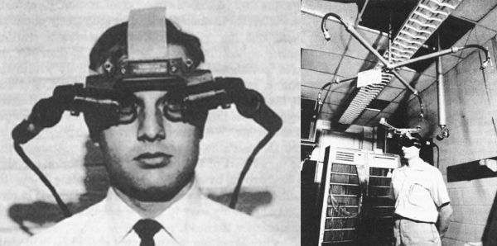

Fig2.1 The first augmented reality head-mounted display (Shore, 2012)

### 2.2.2 Videoplace

In 1975, Myron Krueger (Kipper & Rampolla, 2012) for the first time created ‘Videoplace’ a laboratory that consist of projectors and cameras which allowed users to interact with virtual objects (Fig 2.2) (Matthew, 2017).

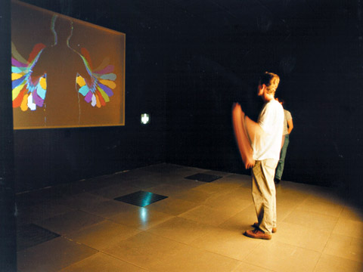

Fig 2.2 Videoplace (Matthew, 2017)

### 2.2.3 AR Powered User Manual

In 1990 Tom Caudell, a researcher in Boeing created an AR powered user manual for the electrical diagrams of flights and replaced the traditional diagrams on a plywood board (Matthew, 2017).

### 2.2.4 ARToolKit

In 1999, Hirokazu Kato, a professor from Osaka University (Matthew, 2017) created and released the ARToolKit to the open source community (Kipper & Rampolla, 2012). The ARToolKit allows for video capture in the real world environment to be combined with virtual objects. This AR kit can be run on any operating system (Kipper & Rampolla, 2012). Currently most of the Flash-based AR that is seen on web browsers uses the ARToolKit (Kipper & Rampolla, 2012).

## 2.3 Augmented Reality on Smartphones

Many smartphone devices such Android and iOS devices has become so sophisticated and powerful in terms of computing and context sensing infrastructure. With many people now a days owning a smartphones, the interaction between the user and augmented reality has allowed this technology to gain attention. Through the smartphone device, the camera allows the user to experience augmented reality with virtual content on their smartphone devices. Currently there are many augmented reality apps available through the iOS app store and Google Play app store (Kim, et al., 2014).

### 2.3.1 Android OS

In 2003, Android Inc. was established by Andy Rubin, Rich Miner, Nick Sears and Chris White. They first focused on implementing Android into digital camera devices. However they later focused on implementing Android on mobile phones. The team developed an operating system for mobile devices which could be aware of both user’s location and their personal preferences. In 2005, Android Inc. was acquired by Google and In October 2008. The first Android OS device was released to the public, the HTC Dream (Brachmann, 2014).

### 2.3.2 iOS

iOS is a mobile operating system developed by Apple Inc. Apple released iOS formerly called iPhone OS on June 29, 2007 (Orf, 2016).

## 2.4 Challenges with Augmented Reality on Smartphones

### 2.4.1 Battery Consumption

Camera sensory on smartphones requires a lot of battery especially when it needs to be constantly running at high frame rates. A smartphone running an AR application can deplete the battery really fast as it is constantly running the camera sensory (Clemens & Dieter Schmalstieg, 2011).

### 2.4.1 Camera Quality

Camera Quality is very important for AR applications to run smoothly, a lot of smartphones cameras in recent years have improved, but some smartphone cameras still suffer from low lighting conditions, this will cause images to become blurry and the colours starts to suffer because it (Clemens & Dieter Schmalstieg, 2011).

### 2.4.2 Network Dependency

Remotely accessing large amount of data can result several implications. If data has to be accessed remotely this can cause lags on the instant behaviour of AR applications. Assessing data remotely also requires network connection, network coverage may not be always available, even if available it may be slow and lastly network connection also requires data plans that can be expensive (Clemens & Dieter Schmalstieg, 2011).

## 2.5 Challenges AR faced both in development and social acceptance

### 2.5.1 Development Challenges

During the early years of augmented reality, in order to use AR application the user had to use a computer and a Head Mounted Display (HMD). During the early years of augmented reality, there was a lack of hardware technology and IT infrastructure that could allow users to fully experience AR. HMD caused inconvenience for the user as the device can interrupt the user’s view of vision. There are more specialised hardware available other than using smartphones such as the Google glasses. The price of the Google glasses is too expensive for a regular consumer. Another challenge is that the current Google glasses cannot be used by a user who requires normal glasses (Kim, et al., 2014).

One of augmented realities most significant technical challenge is object recognition and sensor accuracy. “Objects in the real and virtual world must be properly aligned with respect to each other, or the illusion that the two worlds coexist will be affected, sometimes severely.” “Sensory accuracy applies to mobile AR and the systems that support it” (Kipper & Rampolla, 2012). Many current smart mobile augmented reality devices use one or more of the following tracking technologies: digital cameras and or other types of optical sensors, GPS, gyroscopes, accelerometers, radio-frequency identification (RFID) and wireless sensors. Other challenges augmented reality faces is when handling location-based AR with indoor positioning and line-of-sight. Additionally, many mobile devices have small screen sizes which may affect user experience with AR. There are products like Apple’s iPads and other manufactures tablets that have larger screen sizes that can allow the user to have a richer experience (Kipper & Rampolla, 2012).

### 2.5.2 Social Acceptance Challenges

The final challenge that augmented reality must face is social acceptance. Many people have become accustomed to augmented reality because of entertainment such as movies and television which has used images of simulated AR. Getting or convincing people to wear a augmented reality device can be quite a challenge as they may feel awkward wearing such a device around public. There are also privacy issues that people may be concerned about such as using an augmented reality device to track and record. These issues must be addressed before augmented reality can be fully accepted by the public (Azuma, et al., 2001).

## 2.6 Augmented Reality in Other fields

### 2.6.1 Augmented Reality in Gaming

Pokémon Go (Fig 2.5) released in 2016, was one of the first games to implement geo-located augmented reality elements and It became the most popular game in the history of smartphone games. Over 100 million users from 30 countries downloaded the game (Zsila, 2017).The main goal of Pokémon Go is to capture all Pokémon and to level up as well as to improve their Pokémon stats (Zsila, 2017). Pokémon Go integrates many new areas in computer technology such as a mobile device’s GPS and a camera, real time database interaction, computations, etc. The game uses the user’s geographical location and by moving around in real world environment, the player can find and capture different Pokémon. It also uses geographical location to determine which type of Pokémon will spawn, for example, only some water type Pokémon will appear when you are near water locations (Huang , 2016).



Fig 2.5 Pokémon Go (Mix, 2017)

### 2.6.2 Augmented Reality in Education

One use of augmented reality in education is the use of AR textbooks. The textbooks are just like a normal printed textbooks. What makes it into augmented reality is just by pointing a webcam to the textbooks, this will bring augmented visual and interactive experience to the reader. This technology can also be used by using a smartphone camera and installing a special mobile app (Kesim & Ozarslan, 2012).

### 2.6.3 Augmented Reality in Media & Advertisement

Media & Advertisement, IKEA a swish company that designs and sells ready to assemble furniture, kitchen appliances and home accessories (Loeb, 2013). In September 2017, IKEA lunched their own AR app. The AR app allows customers to visualize what their furniture might look like in their own living rooms, kitchen and bedrooms etc. (Lee, 2017). It allows user to reposition the furniture and the user can move closer or further away from them to view the furniture from different perspective, this allows the user to have a 360 degree view of an furniture (Fig 2.6 and 2.7) (Bell, 2017).

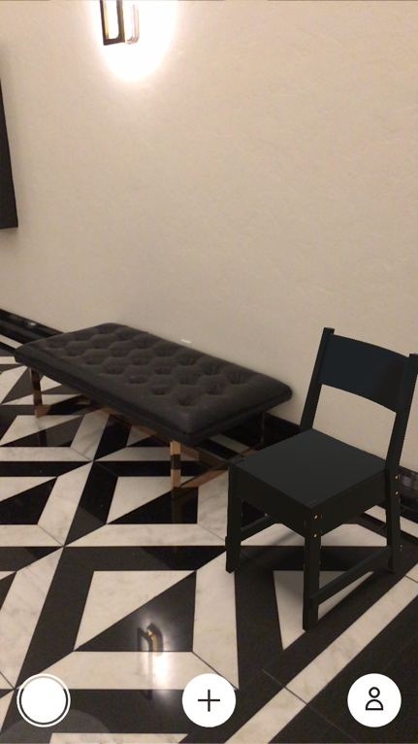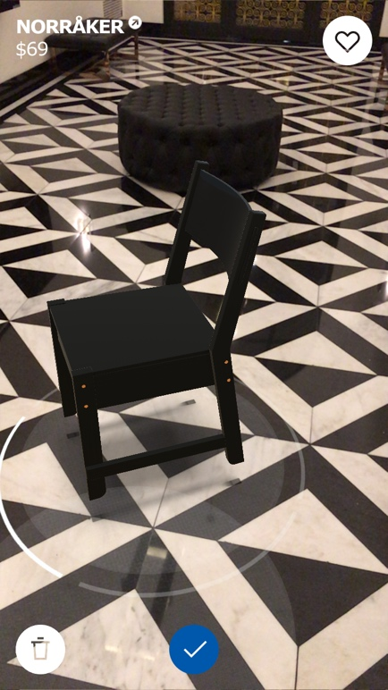  
 Fig 2.6 (Bell, 2017) Fig 2.7 (Bell, 2017)

## 2.7 The Differences between Augmented Reality and Virtual Reality

Augmented reality and Virtual Reality are distinct technologies even though they share some common technology. Virtual Reality (VR) is a completely artificial digital environment that uses computer hardware and software to generate and simulate a real world environment to the user. For a user to have a immersive experience they must first put on special equipment such as special gloves, earphones, and googles, all of which receive their input from the computer system(Fig 2.7). Virtual Reality is full immersion into a simulated world while augmented reality is displaying digital information to a real-world environment. In the end the biggest difference between the two more than anything else is that VR takes place in the real world and AR does not (Kipper & Rampolla, 2012)

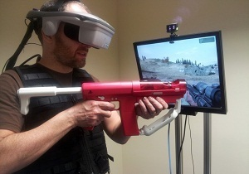

Fig 2.7 Virtual Reality (VR) (Orland, 2012)

## 2.8. Simultaneous Localization and Mapping (SLAM)

Early research of Simultaneous Localization and Mapping (SLAM) technique was focused on how to achieve autonomous control of robots in a robotics review paper by (Taketomi, et al., 2017) which was in (Chatila & Laumond, 1985).SLAM technique provides accurate tracking in unknown and new environments. SLAM refers set of algorithms trying to figure out the pose (position and orientation) estimation and 3D mapping problem simultaneously while a device is moving through the environment (Reitmayr, et al., 2010). Visual SLAM (VSLAM) can be implemented into augmented reality. VSLAM is as stated by Osian Haines “where the primary mode of sensing is via a camera” (Haines, 2016). Marker based AR technology is not SLAM, because the marker based AR image is already known in advance. SLAM must operate in real time, by real-time it means that incoming camera image must be processed by the time a new camera image arrives, by doing this technique the pose of the camera is available immediately, not at the post processing stage. Unlike structure from motion (SfM) technique a stated by Osian Haines “where a set of unordered images are processed offline to recover the 3D structure of an environment” (Haines, 2016). This type technique can be time consuming (Haines, 2016),

## 2.9 Marker-Based and Marker-less Augmented Reality

Marker-based and marker-less AR are two simple types of augmented reality available. Marker- based AR uses a technique that embeds a 3D virtual model into a physical object (Kipper & Rampolla, 2012). Marker-less AR uses positional data such as GPS location of a smartphone (Katiyar, et al., 2015).

### 2.9.1 Marker-Based AR

Maker-based AR uses images that can be detected by a camera and incorporates with a software as the location for a virtual assets to appear on screen. The image is usually black and white (Fig 2.8), however colours can be used as long as the camera can recognizes the contrast between the different colours on the image (Katiyar, et al., 2015). Marker-based AR implementation is ideal for if your environment is fixed or your virtual space does not go beyond the marker-based AR card. (Ufkes & Fiala, 2013)



Fig 2.8 An Example of a marker based AR card (Danny, 2013)

### 2.9.2 Marker-less AR

Maker-less AR collects images from the internet and displayed on any specific location. The data can be gathered by using GPS location. Unlike maker-based applications AR, this does not require any maker to display the virtual assets on screen, this makes maker-less AR application more interactive than marker-based AR applications (Katiyar, et al., 2015)

# 3. Augmented Reality Environment Technologies

## 3.1 AR SDKs

### 3.1.1 Vuforia AR SDK

Vuforia is an augmented reality SDK (software development kit) developed by Qualcomm. It has one of the fastest tracking algorithms available today in the market that is less prone to trackable occlusion and low light conditions. Vuforia is also available for free, but the free version will have a Vuforia watermark on the AR software application. As it is one of the best AR SDK available currently, there is a lot of help and guides available on the internet (Cushnan & El Habbak, 2013). Vuforia make use of the computer vision technology to recognize and track graphic images and 3D objects in real time (Peng & Jing , 2017). As of 2017 Vuforia is now built into Unity 3D 2017, Developers’ no longer have to download a Vuforia SDK from their website and import it to Unity.

### 3.1.2 Use of Vuforia

Vuforia AR is currently is being used in education, instructional, gaming. In Education, Vuforia can be used in museums, the visitors of museum can be see information about the artist or see the unseen in the artwork in an augmented reality way. (Ibanez & Figueras, 2013)

One use of Vuforia in Instructional field is a step by step guide or troubleshooting a product. This type of feature can used with assembling a product, the instructions on how to assemble the product would be in an augmented way. (Ibanez & Figueras, 2013)

In gaming Vuforia is used a lot by developers to develop augmented reality games such as puzzle AR games, strategy AR games etc. (Ibanez & Figueras, 2013)

### 3.1.2 Kudan AR SDK

Kudan is a UK-Japanese company founded in 2011 at Bristol, England (Kudan, n.d.). Kudan AR SDK can support both either marker or maker less tracking and location requirements. It can be ported into any platforms with any peripherals (Kudan, n.d.). Kudan is available for free, but the free version will have a Kudan watermark on the AR software application.

## 3.2 Unity 3D Game Engine

Unity is a cross-platform game engine that is developed by Unity Technologies. Unity has its own IDE (Integrated development environment) built in called Monodevelop. It is the most popular game engine and a free version is available for download. Unity can be deployed on Windows, Mac OS, iOS, Android, web plugins, flash, Microsoft’s Xbox One and Sony’s PlayStation 4 and Nintendo Switch. Unity allows user to use C#, JavaScript or Boo to write your scripts (Cushnan & El Habbak, 2013). Kudan AR SDK and Vuforia AR SDK can be used with Unity for Augmented Reality development.

# Chapter 4: Methodology & Design

### 4.1 Key Findings

In Augmented Reality there are two main types of AR one is the marker based AR technology and the second, would be maker less AR technology. Even though augmented reality technology has been around for a long time, it is only recently that the AR technology started to show its full potential, with many modern smartphones now capable of supporting augmented reality technology.

### 4.2 Research Question

This research is focused on locking and overlapping in augmented reality.

1. Paint over a physical object (e.g. table, floor etc) to display an augmented reality object with the use of augmented reality card.
2. Use of maker based augmented reality card.
3. What happens if an object overlaps a marker based augmented reality card can it still display the augmented reality object?

### 4.3 Project Proposal

This project will be Augmented Reality game project. An augmented reality game will be developed with Unity 3D game engine and it will be developed for an android smartphone device.

### 4.4 System Design

#### 4.4.1 Vision Document

**MoSCoW method:**

**M** = **Must** Have

**S** = **Should** Have

**C** = **Could** Have

**W** = **Won’t** Have

|  |  |  |
| --- | --- | --- |
| 001 | Marker Based AR | Must Have |
| 002 | Multiplayer | Won’t Have |
|  |  |  |

### 4.4.2 Prototypes

#### 4.4.2.1 Vuforia Maker based AR Tutorial sample

|  |  |  |
| --- | --- | --- |
| **Prototype** | **Start Date** | **Finish Date** |
| 1 | 23/09/2017 | 24/09/2017 |

|  |  |  |
| --- | --- | --- |
| **Task Number** | **Details** | **Status** |
| 1 | Download and install Unity 3D and Visual Studio 2013 | Complete |
| 2 | Download Vuforia SDK for Unity 3D  Import Vuforia SDK into Unity 3D | Complete |
| 3 | Create a Vuforia account | Complete |
| 4 | Tutorial on Vuforia Marker based AR  Tutorial link: <https://www.youtube.com/watch?v=oC9k5Yd4020> | Complete |
| 5 | Test Vuforia Marker based AR | Complete |

#### 4.4.2.1 Spaceship Marker less AR

|  |  |  |
| --- | --- | --- |
| **Prototype** | **Start Date** | **Finish Date** |
| 2 | 25/10/2017 | 29/10/2017 |

|  |  |  |
| --- | --- | --- |
| **Task Number** | **Details** | **Status** |
| 1 | Download and install Unity 3D and Visual Studio 2013 | Complete |
| 2 | Download and install Android Studio and configure it correctly. | Complete |
| 3 | Tutorials on Marker less AR without AR SDKs  Tutorial Link:  <https://www.youtube.com/watch?v=T6bd_MQ2ass> | Complete |
| 4 | Connect a suitable Android device to laptop  Build and run the application in Unity 3D | Complete |
| 5 | Test Marker less AR Spaceship Game | Complete |

Write up of key development involved (1/2 paragraphs usually for the prototype, maybe 1 or 2 pages for Sprints)

#### 4.4.2.3 Vuforia AR Marker based Android Tutorial sample

|  |  |  |
| --- | --- | --- |
| **Prototype** | **Start Date** | **Finish Date** |
| 3 | 30/11/2017 | 30/11/2017 |

|  |  |  |
| --- | --- | --- |
| **Task Number** | **Details** | **Status** |
| 1 | Download and install Unity 3D and Visual Studio 2013 | Complete |
| 2 | Download and install Android Studio and configure it correctly. | Complete |
| 3 | Create a Vuforia account | Complete |
| 4 | Tutorials on Vuforia Android Marker based AR  Tutorial Link: <https://www.youtube.com/watch?v=HnjbTytHH6U&ab_channel=Vergium> | Complete |
| 5 | Connect a suitable Android device to connect to laptop  Build and run the application in Unity 3D | Complete |
| 6 | Test Vuforia Android Marker based AR | Complete |

### 4.4.3 Prototype Screenshots

# Chapter 5: Implementation

# **References**

Azuma, R. et al., 2001. Recent advances in augmented reality. *IEEE Computer Graphics and Applications,* 21(6), pp. 34-47.

Bell, K., 2017. *Mashable.* [Online]   
Available at: http://mashable.com/2017/09/24/download-this-ikea-place-ar-kit-app/#tFnSXS8eiiq8  
[Accessed 07 12 2017].

Brachmann, S., 2014. *IP Watchdog.* [Online]   
Available at: http://www.ipwatchdog.com/2014/11/26/a-brief-history-of-googles-android-operating-system/id=52285/  
[Accessed 26 11 2017].

Chatila, R. & Laumond, J.-P., 1985. *Position referencing and consistent world modeling for mobile robots.* St. Louis, IEEE.

Clemens, A. & Dieter Schmalstieg, 2011. *Clemend Arth.* [Online]   
Available at: http://www.arth.co.at/data/papers/challenges.pdf  
[Accessed 28 10 2017].

Cushnan, D. & El Habbak, H., 2013. *Developing AR Games for iOS and Android.* Birmingham: Packt Publishing Ltd.

Danny, M., 2013. *Cross Media Masterpiece.* [Online]   
Available at: https://xmediaramblings.wordpress.com/2013/04/08/workshop-3-week-9-hackathon/  
[Accessed 17 10 2017].

Haines, O., 2016. *Kudan.* [Online]   
Available at: https://www.kudan.eu/kudan-news/an-introduction-to-slam/  
[Accessed 29 10 2017].

Huang , C.-Y., 2016. An Innovative Proposal for Young Students to Learn Computer Science and Technology through Pokemon Go. *2016 International Conference on Computational Science and Computational Intelligence (CSCI),* pp. 246-251.

Ibanez, A. S. & Figueras, J. P., 2013. *UPCommons.* [Online]   
Available at: https://upcommons.upc.edu/bitstream/handle/2099.1/17769/memoria.pdf  
[Accessed 07 12 2017].

Katiyar, A., Kalra, K. & Garg, C., 2015. Marker Based Augmented Reality. *Advances in Computer Science and Information Technology,* 2(5), pp. 441-445.

Kesim, M. & Ozarslan, Y., 2012. Augmented Reality in Education: Current Technologies and the Potential for Education. Volume 47, pp. 297-302.

Kim, S. L. et al., 2014. Using Unity 3D to Facilitate Mobile Augmented. *Using Unity 3D to Facilitate Mobile Augmented.*

Kipper, G. & Rampolla, J., 2012. *Augmented Reality : An Emerging Technologies Guide to AR.* First Edition ed. Waltham: Elsevier Science.

Kudan, n.d. *Kudan.* [Online]   
Available at: https://www.kudan.eu/about/  
[Accessed 11 10 2017].

Kudan, n.d. *Kudan.* [Online]   
Available at: https://www.kudan.eu/kudan-sdk-features/  
[Accessed 11 10 2017].

Lee, D., 2017. *The Verge.* [Online]   
Available at: https://www.theverge.com/2017/9/20/16339006/apple-ios-11-arkit-ikea-place-ar-app  
[Accessed 07 12 2017].

Loeb, W., 2013. *Forbes.* [Online]   
Available at: https://www.forbes.com/sites/walterloeb/2012/12/05/ikea-is-a-world-wide-wonder/#575907ef27b9  
[Accessed 7 12 2017].

Matthew, M., 2017. *linkedin.* [Online]   
Available at: https://www.linkedin.com/pulse/introduction-augmented-reality-ar-moncy-mathew/  
[Accessed 10 04 2017].

Mix, 2017. *The Next Web.* [Online]   
Available at: https://thenextweb.com/gaming/2017/02/14/pokemon-go-monster-trading-battles/#.tnw_vWCNZ9K3  
[Accessed 28 09 2017].

Orf, D., 2016. *Gizmodo.* [Online]   
Available at: https://gizmodo.com/a-brief-history-of-ios-1780790760  
[Accessed 26 11 2017].

Orland, K., 2012. *Ars Technica.* [Online]   
Available at: https://arstechnica.com/gaming/2012/03/virtual-reality-that-doesnt-suck-my-time-inside-half-life-2/  
[Accessed 28 09 2017].

Peng, F. & Jing , Z., 2017. A Mobile Augmented Reality System for Exhibition Hall Based on Vuforia. *2017 2nd International Conference on Image, Vision and Computing (ICIVC),* pp. 1049-1052.

Reitmayr, G. et al., 2010. *Simultaneous Localization and Mapping for Augmented Reality.* Gwangju, South Korea, IEEE.

Shore, J., 2012. *MashableUK.* [Online]   
Available at: http://mashable.com/2012/09/24/augmented-reality/#WPd_bY2ZKsqx  
[Accessed 04 10 2017].

Taketomi, T., Uchiyama, H. & Ikeda, S., 2017. *Visual SLAM algorithms: a survey from,* s.l.: Springer Berlin Heidelberg.

Ufkes, A. & Fiala, M., 2013. *A Markerless Augmented Reality System for Mobile Devices.* Regina, SK, Canada, IEEE.

van Krevelen, D. & Poelman, R., 2010. A Survey of Augmented Reality Technologies, Applications and Limitations. *The International Journal of Virtual Reality,* pp. 1-20.

Zsila, Á. &. G. O. &. B. B. &. T.-K. I. &. K. O. &. G. M. &. D. Z., 2017. *An empirical study on the motivations underlying augmented reality games: The case of Pokémon Go during and after Pokémon fever.* s.l.:s.n.